Topic 🡪Topic Name Spring MVC Spring MVC + Hibernate CRUD

Q1) What is view Resolver?

ViewResolver is an interface to be implemented by objects that can resolve views by name.

It consist of jsp pages .

Q2) Spring MVC flow ?

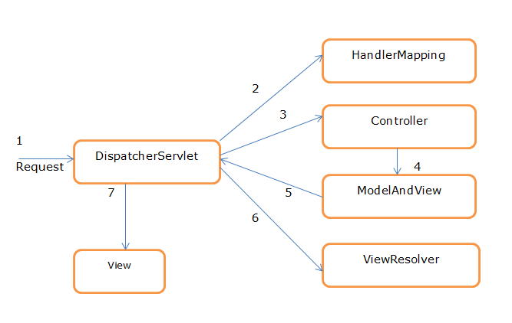

Fig- Spring MVC Flow

**Description-**

Step **1**:

When browser sent the request will be received by DispatcherServlet.

Step **2**:

DispatcherServlet will take the help of HandlerMapping and get to know the Controller class name associated with the given request.

Step **3**:

So request transfer to the Controller, and then controller will process the request by executing appropriate methods and returns ModeAndView object (contains *Model* data and *View* name) back to the DispatcherServlet.

Step 4:

Now DispatcherServlet send the model object to the ViewResolver to get the actual view page.

Step **5**:

Finally DispatcherServlet will pass the *Model* object to the *View* page to display the result.

## Q2) Dispatcher Servlet ?

In Spring MVC all incoming requests go through a single servlet is called Dispatcher Servlet (front controller).

The front controller is a design pattern in web application development.

A single servlet receives all the request and transfers them to all other components of the application.

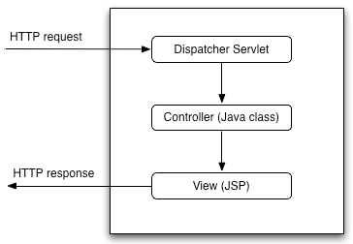

The job of DispatcherServlet is to take an incoming URI and find the right combination of **handlers** (Controller classes) and **views** (usually JSPs).

When the DispatcherServlet determines the view, it renders it as the response.

Finally, the DispatcherServlet returns the Response Object to back to the client. In short, the Dispatcher Servlet plays the key role.

Q3) What is controller ?

**Controller**- provides information between model and view. It contains the logical part of the application. *@Controller* annotation is used to mark that class as controller.

Q4) what are the bean scopes in mvc ?

* **singleton**

This scopes the bean definition to a single instance per Spring IoC container (default).

* **prototype**

This scopes a single bean definition to have any number of object instances.

* **request**

This scopes a bean definition to an HTTP request. Only valid in the context of a web-aware Spring ApplicationContext.

* **session**

This scopes a bean definition to an HTTP session. Only valid in the context of a web-aware Spring ApplicationContext.

* **global-session**

This scopes a bean definition to a global HTTP session. Only valid in the context of a web-aware Spring ApplicationContext.

Q5) What is front controller in MVC?

* **Front Controller** - Single handler for all kinds of requests coming to the application (either web based/ desktop based).

Q6) spring hibernate integration ?

We can simply integrate **hibernate application with spring application**.

In hibernate framework, we provide all the database information hibernate.cfg.xml file.

But if we are going to integrate the hibernate application with spring, we don't need to create the hibernate.cfg.xml file. We can provide all the information in the applicationContext.xml file.

Q7) Can we have multiple DispatcherServlet ?

**You can have as many DispatcherServlets as you want**.

Basically what you need to do is duplicate the configuration and give the servlet a different name (else it will overwrite the previous one), and have some separate configuration classes (or xml files) for it.